Name:
Harder
Easier
1 | 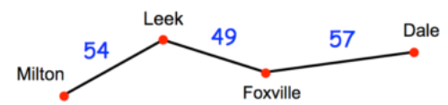  The diagram above shows distances between towns. How far is it from Milton to Dale? | At a Burnley football match there were 21 235 Burnley supporters and 5 764 Blackburn supporters. How many more Burnley supporters were there? | 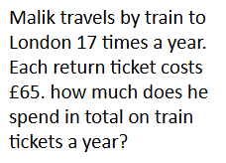 | 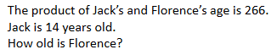
2 | Write the following in digits:  Forty three thousand, five hundred and seven. | Put the following numbers in ascending order: 4308, 4380, 784, 4083, 4038 | Put the following numbers in ascending order: 2.604, 6.320, 6.0324, 0.364, 0.436 | Put the following numbers in ascending order:  2.6, 2$\frac{1}{2}$, 2.025, -2.8, 2$\frac{5}{6}$
3 | Calculate 7 - 11 = | Calculate -16 + 5 = | What is -45 $÷$ 9 = | What is -32 x -3?
4 | 3² = | 2 + 3 x 4 = | 2 + (2x3) = | 3 + 4 $÷$2² =
5 | Calculate 7² = | Calculate:  3² x 2² = | Calculate:  9⁰ = | Simplify:  12⁶ x 12²=
6 | Calculate 10⁵ = | Write 6.2 x 10⁵ in ordinary form. | Write 32 800 000 in standard form. | Write 0.0000067 in standard form.

